Digital Signal Processing
Year : 2016-17 Div : B.E. A,B,C
Lecture – 24

- List properties of DFT and prove with example
  - Frequency Shift
  - Time Reversal
  - Convolution Property
- How signal energy can be calculate in time and Fourier domain?

q.1.)Convolution
The convolution of two functions f(x) and g(x) is defined by the integral:
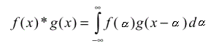
The Convolution Theorem tells us that convolution in the spatial domain corresponds to multiplication in the frequency domain, and vice versa.
Translation or Shifting
The FT of a shifted function is unaltered except for a linearly varying phase factor.

The DFT and IDFT are periodic with period N ; that is:

